BIT4107: MOBILE APPLICATION DEVELOPMENT REPORT

ANDROID STUDIO INSTALLATION & DEVELOPMENT LOGBOOK

TradeLinkEastAfrican app
Presented by: James Mam
Admission Number: BIT/2024/56261
Submitted to: Mr. Nyoro
Date: June 2026

INITIAL ENVIRONMENT SETUP & ARCHITECTURE

Task 1: Installing the Flutter SDK and IDE Workspace

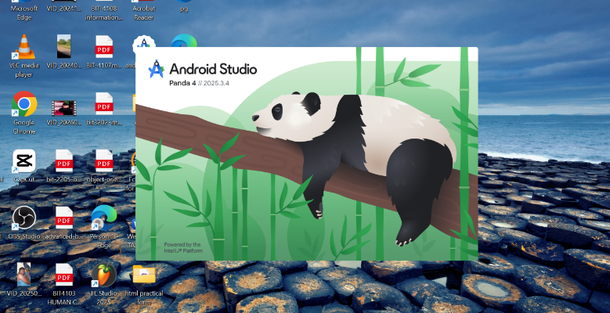

Creating a New Project & Directory Setup
Task 2:Project Creation and Cross-Platform Structure
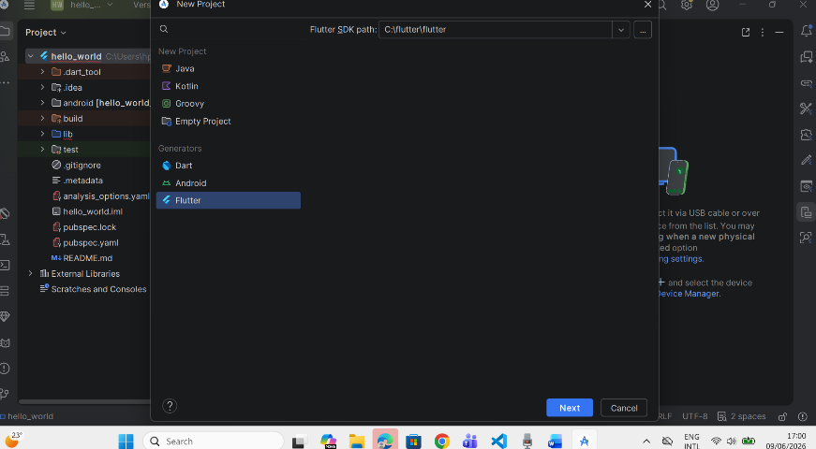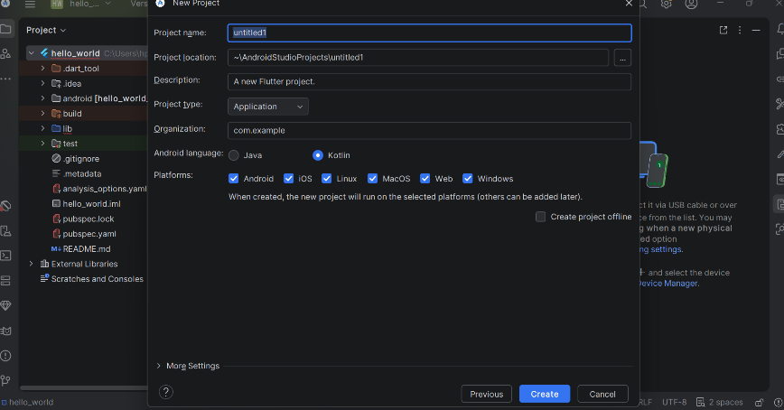

Task 3: Main Code Implementation (lib/main.dart

import 'package:flutter/material.dart';
void main() {
runApp(const TradeLinkApp());
}
class TradeLinkApp extends StatelessWidget {
const TradeLinkApp({super.key});
@override
Widget build(BuildContext context) {
return MaterialApp(
debugShowCheckedModeBanner: false,
title: 'TradeLink East Africa',
theme: ThemeData(
useMaterial3: true,
colorSchemeSeed: Colors.green,
),
home: const HomeScreen(),
);
}
}
class HomeScreen extends StatefulWidget {
const HomeScreen({super.key});
@override
State<HomeScreen> createState() => _HomeScreenState();
}
class _HomeScreenState extends State<HomeScreen> {
int currentIndex = 0;
final List<Widget> pages = [
const DashboardPage(),
const ProductsPage(),
const MarketplacePage(),
const ProfilePage(),
];
@override
Widget build(BuildContext context) {
return Scaffold(
body: pages[currentIndex],
bottomNavigationBar: NavigationBar(
selectedIndex: currentIndex,
onDestinationSelected: (index) {
setState(() {
currentIndex = index;
});
},
destinations: const [
NavigationDestination(
icon: Icon(Icons.home),
label: 'Home',
),
NavigationDestination(
icon: Icon(Icons.inventory),
label: 'Products',
),
NavigationDestination(
icon: Icon(Icons.store),
label: 'Market',
),
NavigationDestination(
icon: Icon(Icons.person),
label: 'Profile',
),
],
),
);
}
}
class DashboardPage extends StatelessWidget {
const DashboardPage({super.key});
@override
Widget build(BuildContext context) {
return Scaffold(
appBar: AppBar(
title: const Text("TradeLink East Africa"),
backgroundColor: Colors.green,
foregroundColor: Colors.white,
),
body: Padding(
padding: const EdgeInsets.all(16),
child: Column(
children: [
Card(
elevation: 5,
child: ListTile(
leading: const Icon(Icons.trending_up,
color: Colors.green),
title: const Text("Trade Opportunities"),
subtitle: const Text(
"Connect businesses across East Africa"),
),
),
const SizedBox(height: 15),
Row(
children: [
Expanded(
child: Card(
color: Colors.green.shade100,
child: const Padding(
padding: EdgeInsets.all(20),
child: Column(
children: [
Icon(Icons.shopping_cart, size: 40),
Text("Products"),
Text("120+"),
],
),
),
),
),
Expanded(
child: Card(
color: Colors.blue.shade100,
child: const Padding(
padding: EdgeInsets.all(20),
child: Column(
children: [
Icon(Icons.people, size: 40),
Text("Businesses"),
Text("50+"),
],
),
),
),
),
],
),
],
),
),
);
}
}
class ProductsPage extends StatelessWidget {
const ProductsPage({super.key});
@override
Widget build(BuildContext context) {
return Scaffold(
appBar: AppBar(title: const Text("Products")),
body: ListView(
children: const [
ListTile(
leading: Icon(Icons.agriculture),
title: Text("Coffee"),
subtitle: Text("Kenyan Export Product"),
),
ListTile(
leading: Icon(Icons.grass),
title: Text("Tea"),
subtitle: Text("East African Tea"),
),
ListTile(
leading: Icon(Icons.shopping_bag),
title: Text("Textiles"),
subtitle: Text("Local Manufacturing"),
),
],
),
);
}
}
class MarketplacePage extends StatelessWidget {
const MarketplacePage({super.key});
@override
Widget build(BuildContext context) {
return Scaffold(
appBar: AppBar(title: const Text("Marketplace")),
body: Center(
child: ElevatedButton.icon(
onPressed: () {},
icon: const Icon(Icons.add_business),
label: const Text("Post Trade Offer"),
),
),
);
}
}
class ProfilePage extends StatelessWidget {
const ProfilePage({super.key});
@override
Widget build(BuildContext context) {
return Scaffold(
appBar: AppBar(title: const Text("Profile")),
body: const Center(
child: Column(
mainAxisAlignment: MainAxisAlignment.center,
children: [
CircleAvatar(
radius: 50,
child: Icon(Icons.person, size: 50),
),
SizedBox(height: 10),
Text(
"TradeLink User",
style: TextStyle(
fontSize: 20,
fontWeight: FontWeight.bold,
),
),
],
),
),
);
}
}
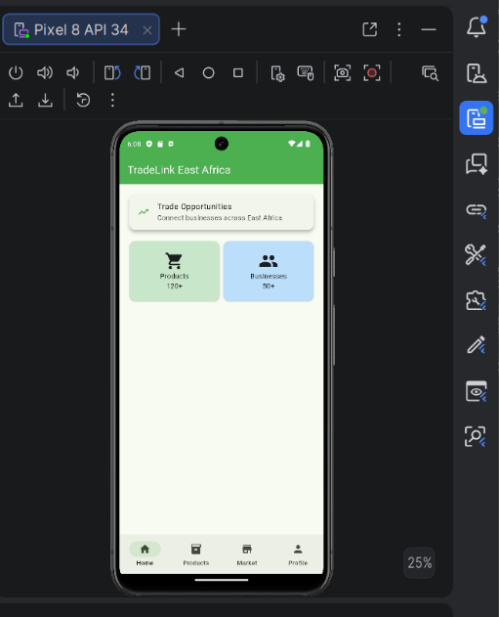
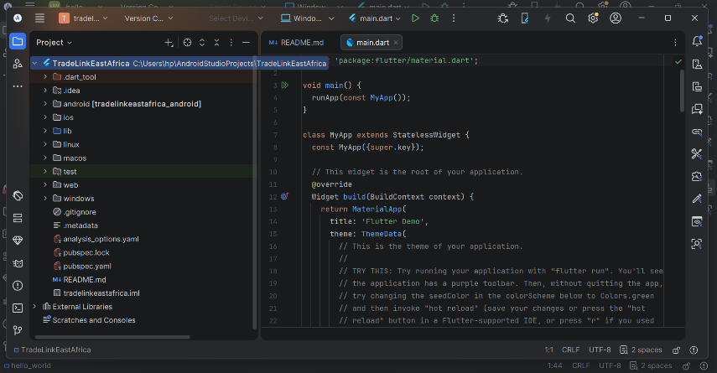
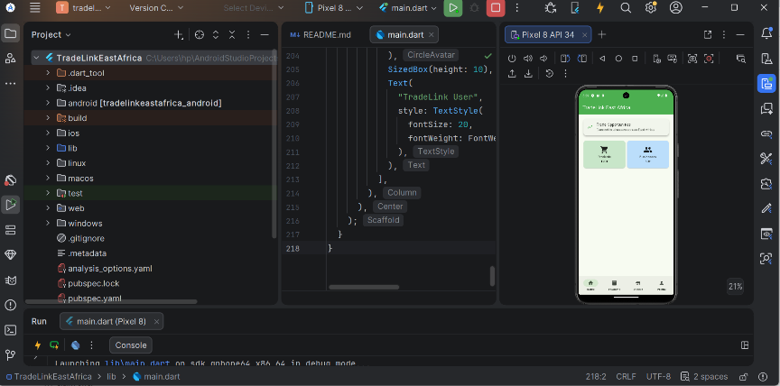

Configuring Project Preferences

Opened the system settings to verify active SDK platforms, developer plugins, and editor configurations required to write and compile the application code cleanly. Settings verified for active coding deployment.

